DRAFT V1

Broadcast Services & Operations

*Catalogue of Services*

A. COMPETITION VENUE SERVICES AND FACILITIES 2

1. Stadium Facilities 2

1.1. Non Equipped Positions 2

a. Non-equipped Regular Commentary position 2

b. Non-equipped Multilateral Interviews Positions 2

c. Pre and Post Match non equipped positions 3

d. VIP Position 3

e. Pitch Level Positions 4

f. Non Equipped Post-Match Interview Positions 5

g. Non equipped Mixed Zone Interview Position: 5

h. None equipped Press Conference Camera Position: 6

1.2. Equipped Positions (TBD) 6

1.3. Presentation Studio 6

1.4. Presentation Platform 7

1.5. TV/Interview Studio: 7

1.6. Venue Broadcast Compound Facilities 7

a. Compound Positions for OB Van or SNG 8

b. Parking for Support Vehicles: 8

c. Cabins 8

1.7. Media Facilities Access 8

B. Non-Competition venue - Main Media Center 9

1. Press Conference 9

2. Main Media Center - Studio 9

# COMPETITION VENUE SERVICES AND FACILITIES

## Stadium Facilities

### Non Equipped Positions

#### Non-equipped Regular Commentary position

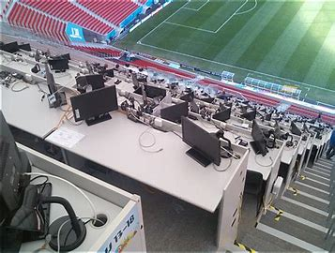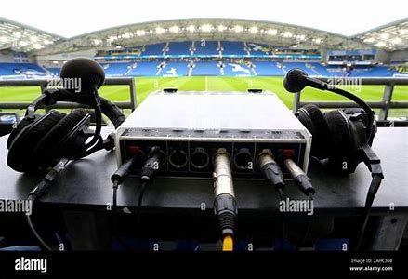

This Position is located on the media tribune

- 1 x desk for up to 3 people

- 2 x TV Sets connected to the Broadcast /Media CATV system

- Broadcast Power

- Commentary position per number of matches

- Connection to Internet Access

#### Non-equipped Multilateral Interviews Positions

A selection of multilateral interview positions is made available Live on the respective Team A/B Feed and Live/Delayed on the Tactical & Additional Content Feed. (MePs need to bring their Live U)

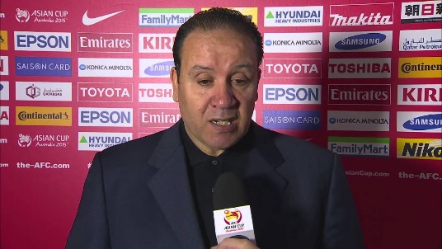Interviews can only be booked and conducted by MePs whose national teams are playing in the given match, they are considered multilateral, meaning made for the benefit of the whole MeP community broadcasting the relevant Match.   If not booked, these interviews will be made by a BRO Services Venue Manager.

* Team Arrival Multilateral Interview Position Brief interviews (one interview per playing team, 90 seconds max each) of coaches or assistant coaches may be conducted at the time of the team arrival. Interviews are captured by HB in front of the official backdrop. The signal is delivered available live on the respective Team A/B Feed and Live/Delayed on the Tactical & Additional Content Feed. Reporter cannot be on camera (multilateral content). MeP’s flag on the microphone is not authorized.
* Half-Time Multilateral Flash Interview Position Flash interviews (90 seconds max each) of coaches or assistant coaches (no players) may be conducted at Half Time in the designated area near the tunnel. One interview per playing team may take place. Interviews are captured by HB in front of the official backdrop. Reporter cannot be on camera (multilateral content). MeP’s flag on the microphone is not authorized.
* Full-Time Multilateral Flash Interview Position Flash interviews (90 seconds max each) of players and/or coaches may be conducted at the end of the match in the designated area close to the pitch. Two interviews per playing team may take place (typically the coach and one player). Interviews are captured by HB in front of the official backdrop. Reporter cannot be on camera (multilateral content). MeP’s flag on the microphone is not authorized.

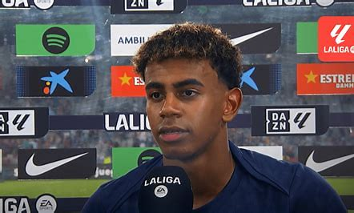

These interviews are usually free of charge.

#### Pre and Post Match non equipped positions

* Pitch-Side Announce Position: Two non equipped, located at pitch level are available in 10-minute slots for pre-match stand-ups or interviews with guests.
* Outside non equipped Announce Position: Up to 4 partially non equipped positions, can be available outside of each Stadium, offering a view to the supporters’ arrival.

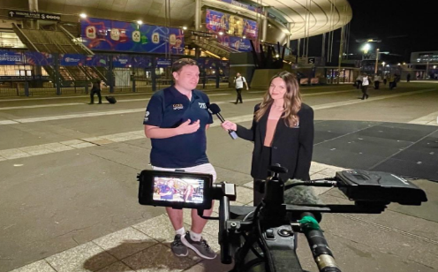

#### VIP Position

Two interview positions can be booked by MePs on a per-match basis. This service is activated pre-Match only and interviews must be conducted in front of the official backdrop. It is recommended that the MeP contacts the relevant VIP (or its management) in advance to arrange such interviews. It is at VIP's discretion to accept being interviewed. Interviews of coaches or players are not allowed.

#### Pitch Level Positions

When booked on Match Day, Pitch-Level Positions are also available for broadcast on Match Day-1.

* Non - equipped Pitch-Side Presentation Position:

Up to 4 Pitch-Side Presentation Positions are available at each venue behind the goal lines. From 3 hours until 15 minutes before Kick-Off, at Half-Time and after the Final Whistle, stand-ups are permitted. At Half-Time and after the Final Whistle, the positions can only be used once all players have left the playing area. Interviews of players or coaches are not allowed.

Access and Power should be provided. The camera can stay during the match as a unilateral camera position.

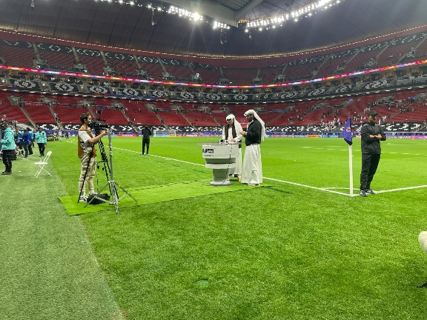

* Non - equipped Pitch Reporter Position:

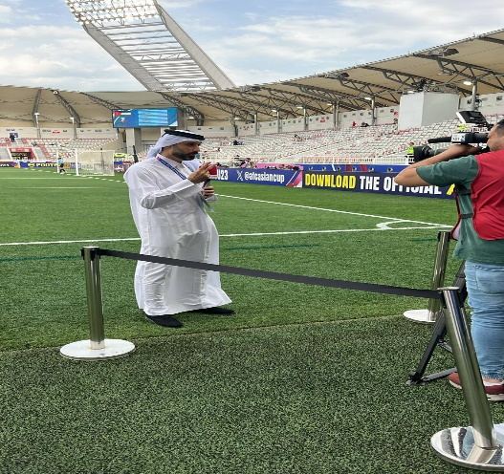From 15 minutes prior to Kick-Off, the pitch reporter must remain at his/her designated position, behind unilateral camera positions. This position is for MePs with on-site production means at the Broadcast Compound only. Interviews of players or coaches are not allowed.

The service includes - Access for one reporter Pitch reporter equipment must be provided by the MeP and approved by HB.

* Pitch-Side Announce Position:

Several Pitch-Side Announce Positions of 2m x 3m, located at pitch level along the touchline, are available for MePs on a per-match basis

From 3 hours until 15 minutes before Kick-Off, at Half-Time and after the Final Whistle, once all players have left the playing area, standups are permitted at the designated position. Interviews of players or coaches are not allowed.

#### Non Equipped Post-Match Interview Positions

These interviews will take place at the same time after the match in the Unilateral Flash Interview Areas, TV/Interview Studios and Mixed Zones.

Players and Coaches will be available for interviews in these areas once they have left the field of play, at the Final Whistle, and after completing any requested multilateral Flash Interviews.

MeP’s requests for Player/Coach interviews in Unilateral Flash Positions and TV/Interview Studios will take priority over Players/Coaches entering the Mixed Zone. After passing through the Mixed Zone, Players will return to the Dressing Rooms.

* Post-Match Unilateral Flash Interview Position:

Up to 6 Post-Match Unilateral Flash Interview positions, located in a dedicated area between the pitch and the dressing rooms are available at each venue. Unilateral Flash Interviews take place in front of the backdrop in the designated area. MePs having booked the service are allowed to conduct several short (90 sec. each) interviews. Coaches or players may be interviewed, but only once they have completed any multilateral flash interview requirements.

Broadcast Power, Backdrop and access should be available.

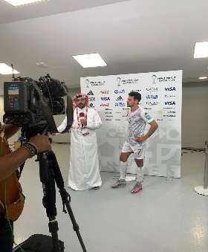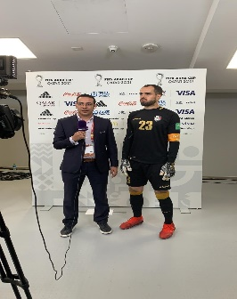

#### Non equipped Mixed Zone Interview Position:

Can be booked on a per-match basis. These positions can only be used for post-match activities. The service includes:

Access for 1 camera operator

Backdrop

Power

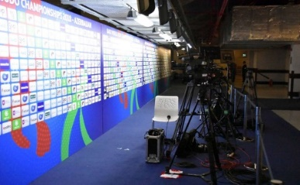Equipment to be provided by the MeP (1 camera max.)

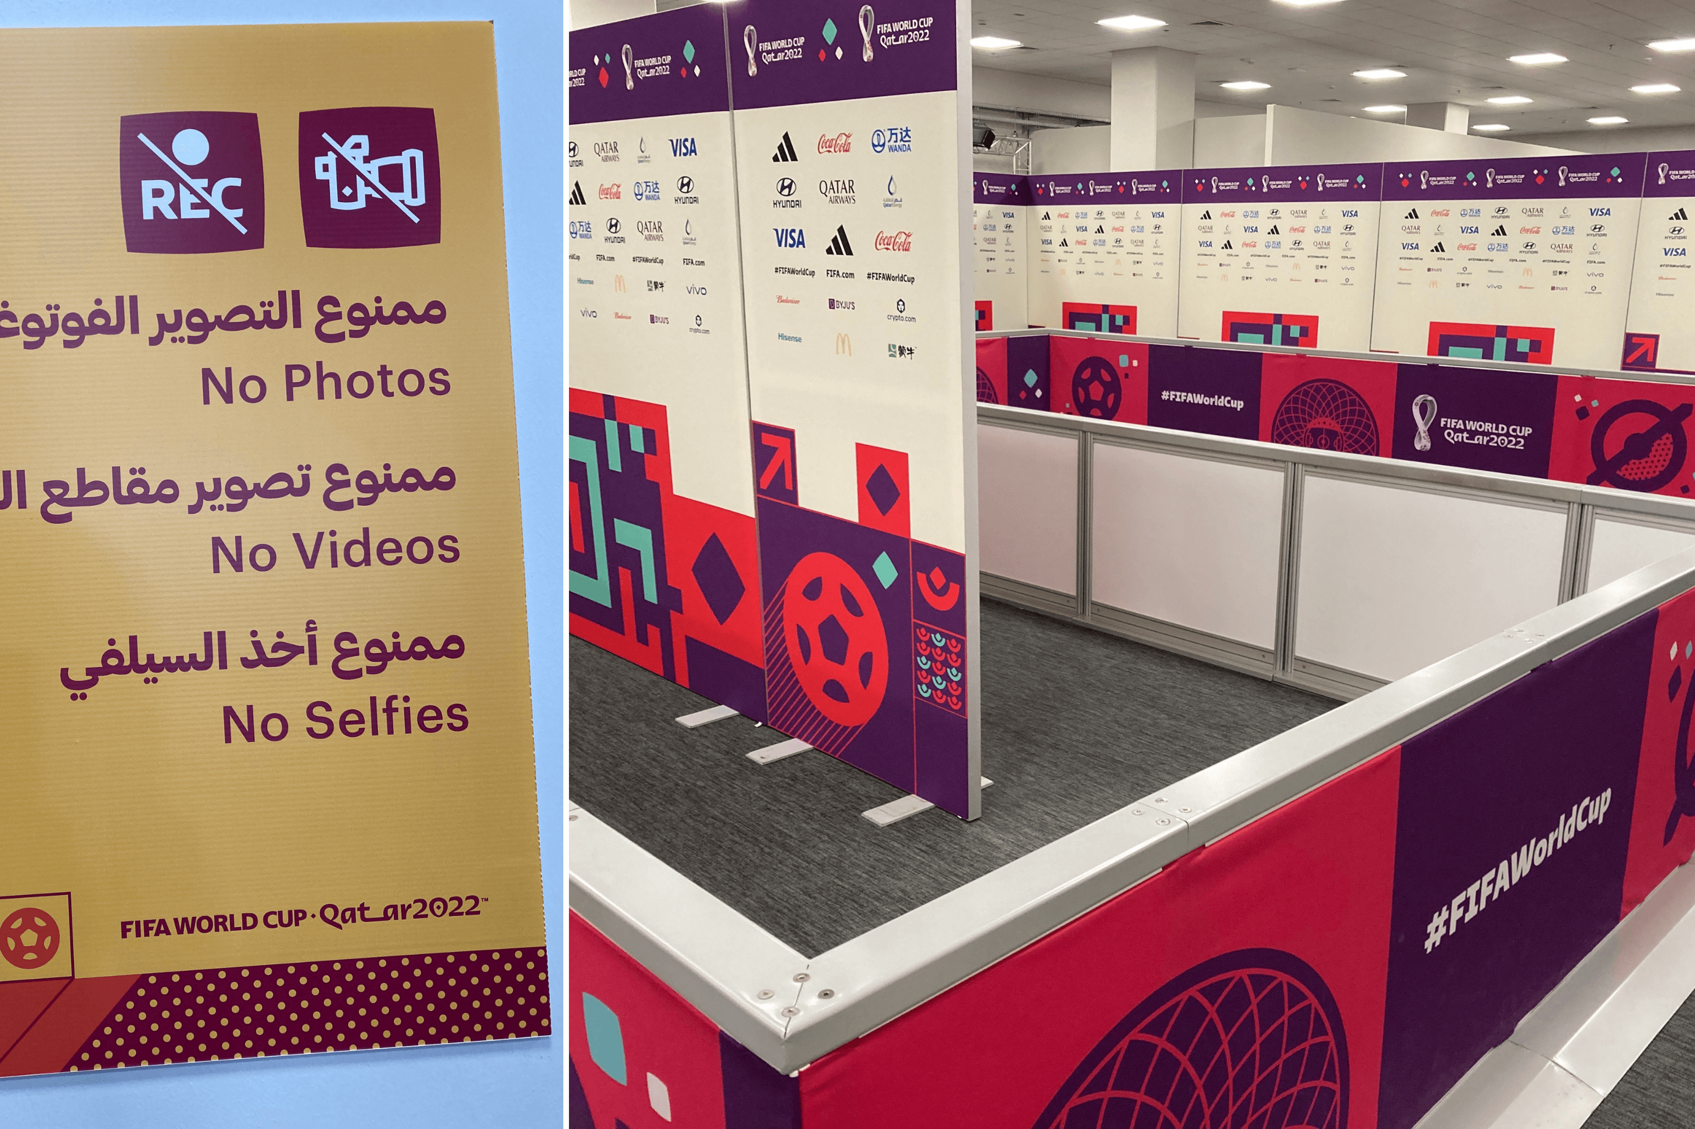

#### Non equipped Press Conference Camera Position:

Up to 4 positions, located on the Press Conference camera platform, can be booked on a per-match basis. These positions can only be used for post-match activities.

The service includes:

- Access for 1 camera operator

- Power

Equipment to be provided by the MeP (1 camera max.)

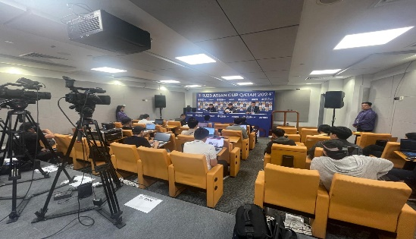

### Equipped Positions (TBD)

All services/ positions mentioned above can be offered as equipped or partially equipped depending on the agreement with the HB/ Technical provider.

### Presentation Studio

Presentation Studios offering a view to the pitch are available at each venue.

Internet & Power are to be offered in the presentation studios.

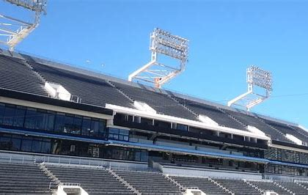 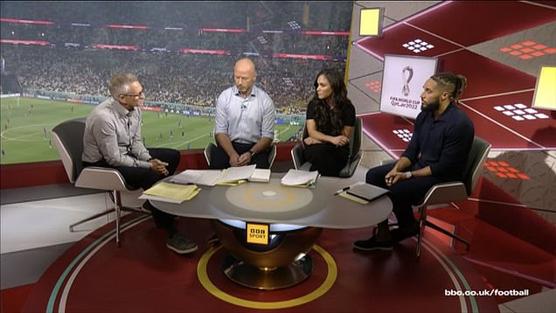

All equipment and furniture to be provided by MePs.

### Presentation Platform ***(currently not installed)***

Up to 2 Presentation Platforms located in the stands, each a minimum of 5m x 5m, provide a general background view of the inside of the stadium. This dedicated service is available on Match Days, from 3 hours before kick-off until 1 hour after final whistle

The service includes: - Access in accordance with MeP’s production plan approved

Broadcast Technical Power

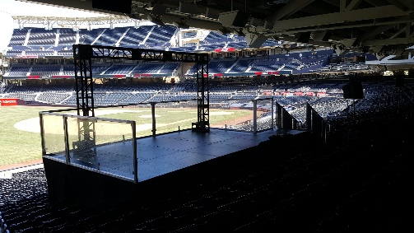

Equipment must be provided by the MePs (2 cameras max. and TV lighting)

### TV/Interview Studio:

Partially non equipped TV/Interview Studios, located close to the dressing rooms. This facility is bookable on a dedicated basis, for post-match interviews until one hour after the Final Whistle. Coaches or players may be interviewed, but only once they have completed any multilateral flash interview requirements.

The service includes:

- Access in accordance with production plan approved

- TV lighting and backdrop –

- Power

- 1 x table, 3 x chairs other equipment to be provided by the MeP.

TV/Interview Studios are available on Match Day-1 for set-up purposes only.

### Venue Broadcast Compound Facilities

Broadcast Compound space for OB Vans, SNGs and associated technical vehicles, as well as cabins for technical or office space will be made available at each Venue depending on requests.   MePs having booked space for an OB Van, SNG or a Technical Cabin will automatically access, at the CIR in the Broadcast Compound.

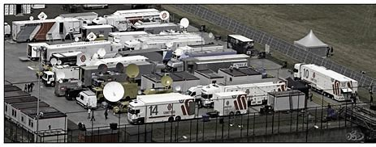

Many signals can be booked.

Cabling between the vehicles and the CIR and to the power outlet is the responsibility of the MePs, under the supervision of HB. Adapting BTP to individual needs, in terms of plug sizes and voltage, is the MePs’ responsibility

#### Compound Positions for OB Van or SNG

The service includes:

- Access for one vehicle

- Access to the match coverage

- Power

- Access to Wifi shared internet access.

MePs will be required to provide details of their vehicles and schedules.

#### Parking for Support Vehicles:

Limited space is available in each Broadcast Compound for support vehicles;

Support vehicles cannot access feeds nor power.

#### Cabins

Cabins can be booked for office or technical purposes as follows:

- Per match: the cabin is allocated to an MeP for 2 days, including MD-1. Due to match schedule constraints, handover of the cabins will have to be managed thoroughly with the HB team on site.

- Per venue: the cabin is dedicated to an MeP for the entire duration of the venue activation.

The service includes:

* Space in the Broadcast Compound
* Single or double unit, as indicated
* Provision of office light, Power and HVAC (basic air conditioning) - - Basic Furniture (list is for single cabin): 2 x Desks with Drawers 4 x Chairs 1 x Bookshelf 1 x Coat Stand 2 x Waste Bins 2 x Desk Lamps Cabin keys.

### Media Facilities Access

For each match, accredited MeP personnel can access - on a free of charge basis - the Media Facilities listed below.

To permit a fair management of these positions to MePs, no-shows are monitored and taken into account when positions are allocated for subsequent matches. A shared connection is provided free of charge by the LOC for basic internet access. It is not intended for streaming (neither in nor out), video or audio content.

* Observer Seat

A limited number of observer seats, located close to the commentary area, are available to MePs on a per-match basis. Observer Seats will be allocated by priority to MePs having booked other services for the related match.

* Press Conference

Limited Press Conference access is available to MePs on a per-match basis.

TV Camera Press Conference Access (1 person with 1 ENG camera) - per match

* Mixed Zone

Limited Mixed Zone access is available to MePs on a per-match basis.

Access (1 person with 1 camera) - per match free of charge

Mixed Zone Access for 1 person - per match free of charge

* Parking Pass

A limited number of venue access parking passes are available to MePs on a per-match basis.

Parking Space for 1 car - per match

# Non-Competition venue - Main Media Center

## Press Conference (TBC)

Access is available to MePs on press conferences that will take place in the MMC

TV Camera Press Conference Access (1 person with 1 ENG camera) - per match

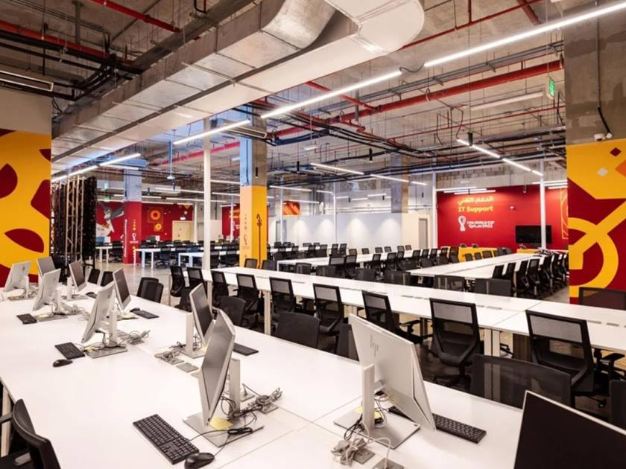

## Main Media Center - Studio

Non-equipped TV/Interview Studio with basic furniture. This facility is bookable on a dedicated basis, for MD-1 interviews. Coaches or players may be interviewed.